Supplementary Material

Figure S1. The medial nucleus accumbens showing a moderate value x condition interaction effect
A. The medial nucleus accumbens shows a moderate value x condition interaction effect at the group random effects level (x = 0, y = 12, z = 0, Z = 3.16, p < 0.005, uncorrected). B. Plot of parameter estimates derived from the peak voxel in the random effect group analysis shows that effects in this region were mostly driven by differences in responses to the anticipation of the aversive outcomes between the reinforcers.

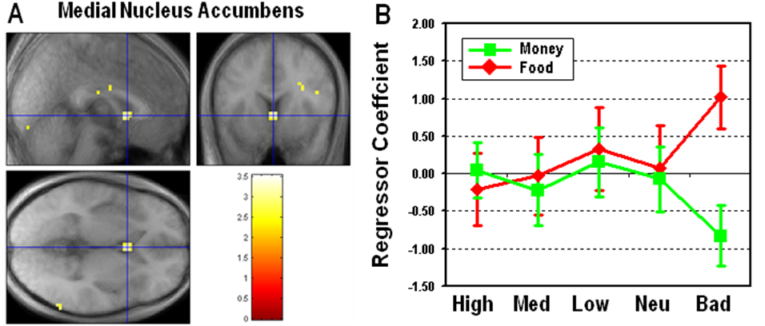
Figure S2. Brain regions within vmPFC encoding the value of juice and money outcomes at the time of outcome presentation. Statistical maps depicting positive-value related responses to the receipt of juice (shown in red) and money (shown in green) outcomes, overlaid on a subject averaged T1 scan. (p < 0.005, uncorrected)

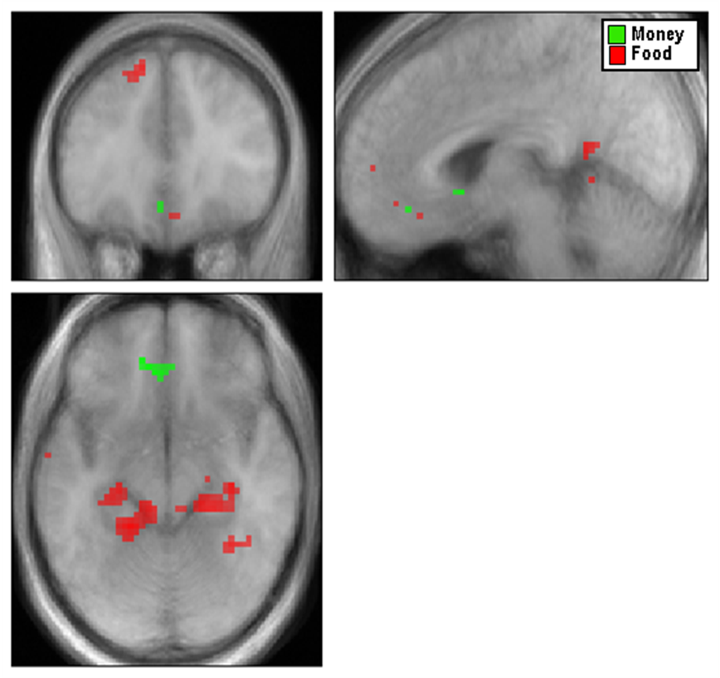

Figure S3. Group statistical maps showing areas with monotonically increasing responses to the value of an expected outcome for juice and money from the analysis without orthogonalization.
To rule out the possibility that the vmPFC activation for juice and money expectation are due to BOLD responses to outcomes rather than cues, we examined the expected value coding in vmPFC without orthogonalizing regressors for outcomes with respect to those for cues. This additional analysis replicated both juice (A) and money (B) value signals at a slightly weaker threshold, indicating that the colinearity was not a major problem.

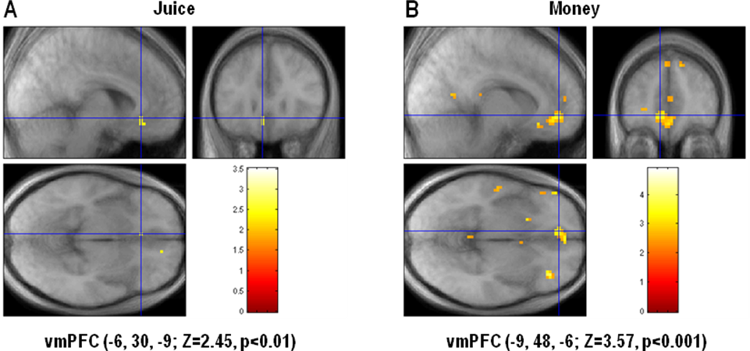
SI Table 1. Brain areas showing monotonically increasing (or decreasing) responses to the value of an expected outcome for juice and money. All are significant at p < 0.001, except for * (p < 0.005).

Brain region | Z | x y z (peak in MNI)
Monotonically increasing response to juice value
Ventromedial Prefrontal Cortex (Left) | 2.84* | -6 27 -15
Posterior thalamus (Left) | 3.37 | -24 -27 0
Monotonically increasing response to money value
Ventromedial Prefrontal Cortex (Left) | 4.42 | -6 36 -12
Superior Frontal Cortex (Left) | 3.96 | -27 21 60
Middle Temporal Cortex (Left) | 3.41 | -51 -12 -18
Monotonically decreasing response to juice value
Middle Frontal Cortex (Right) | 4.16 | 33 9 27
Anterior Insula (Right) | 3.62 | 27 33 6
Anterior Insula (Left) | 3.93 | -33 30 6
Monotonically decreasing response to money value
Anterior Insula (Right) | 4.25 | 36 24 3
Anterior Insula (Left) | 3.47 | -39 12 3
Anterior Cingulate Cortex (Left) | 3.49 | -12 9 45

SI Table 2. Brain areas showing monotonically increasing (or decreasing) responses to the outcome delivery for juice and money. All are significant at p < 0.001, except for * (p < 0.005).

Brain region | Z | x y z (peak in MNI)
Monotonically increasing response to juice delivery
Ventromedial Prefrontal Cortex (Right) | 2.67* | 3 45 -12
Parahippocampal Gyrus (Left) | 4.05 | -12 -30 -18
Parahippocampal Gyrus (Right) | 3.91 | 30 -30 -18
Posterior Cingulate Cortex | 3.92 | -6 -54 18
Monotonically increasing response to money delivery
Ventromedial Prefrontal Cortex (Left) | 3.47 | -6 36 -12
Superior Frontal Cortex (Left) | 3.23 | -21 12 60
Nucleus Accumbens | 3.53 | 0 12 -6
Monotonically decreasing response to juice delivery
Inferior Frontal Cortex (Left) | 3.71 | -57 15 12
Anterior Insula (Left) | 2.76* | -36 27 3
Monotonically decreasing response to money delivery
Posterior Orbitofrontal Cortex (Right) | 3.16 | 48 24 -6
Middle Frontal Cortex (Right) | 3.15 | 48 18 42
Anterior Cingulate Cortex (Left) | 3.98 | 12 33 42
Posterior Thalamus (Right) | 3.72 | 12 -12 -6

